NISSAN YD 25 INJECTOR CLAMP
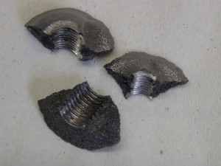Cylinder heads have been seen that show vertical and horizontal cracks in the injector clamp lodging. In several cases finally have separate material of the threads of the base. This is caused by clear over-torque.of the material elastic limit is exceeded and the wall is broken by traction when tightening the injector bolt.
OE and AMC in its Assembly Manual and in the technical note included with the head (see attached doc), clearly state to tight this M-8 bolt in between 25-28 Nm. the customer has to be very carefully when applying the required torque and checking the correct calibration of the used torque wrench.
In the tests carried out in the lab to verify the actual breaking point of the injector clamp lodgings of this cylinder head family, the results have been that plastic deformation started after applying between 50-55 Nm.
