TOYOTA 3.0 (1KZT – 1KZTE)
BRIDGE OVER-TIGHTENING OF THE CYLINDER HEADS ON THE TOYOTA 3.0 (1KZT – 1KZTE)
We have seen cases in which clients indicate that the camshaft for these engines becomes blocked, thus preventing rotation.
The actual cause of this problem is the deformation produced by over-tightening its screws, which is producing the ovaling and conicity of the internal camshaft borings. The bridge is squashed onto the cylinder head and the aluminium bridge base resulting in this bridge deforming inwards when this combination of perpendicular forces occurs.
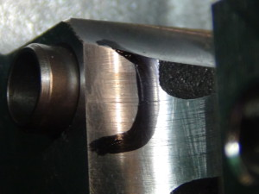
Click on image to enlarge
The “Instruction Sheet” that is included in each packing box with the cylinder head indicates that the bridge screw tightening torque must not exceed 18 Nm, otherwise their design means they are liable to suffer permanent deformation. Their numeration must also be maintained.

