Here Today, For A Better Tomorrow
Introducing ecoLAST™ filters, a revolutionary new heavy duty oil filter made by WIX Filters that reduces downtime, increases uptime and extends useful oil life 2X.
But that’s only half of its exciting story. While great for heavy duty vehicles, ecoLAST™ filters are even better for the environment. That’s because it doubles oil drain intervals. Yes, doubles. It also protects the DPF when using CJ-4 oil, assists in Green Fleet Certification and keeps the additives package fresh over time.
Saving Time, Money, Man Hours and the Environment
ecoLAST™ filters truly are a game-changing filter in many different ways. Not only does it double oil life, but depending on the size of your fleet, it can save your company millions of dollars on oil, filters, man hours and operating costs. The future of heavy duty fleet maintenance has definitely arrived.
It’s true that most filtration companies have a heavy duty extended mileage filter offering. But, many contain slow-release additives, and/or require bypass filtration that can necessitate a costly vehicle modification. That’s not the case with ecoLAST™ filters. It’s a ‘direct replacement’ filter with no changes or modification required to the vehicle. Simply install it and immediately begin reaping the economic and environmental benefits.
Potential Annual Material Cost Savings
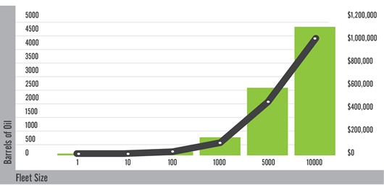
The Science Behind The Savings
WIX ecoLAST™ oil filters capture dirt and soot like a traditional filter, while utilizing cellulose/polyester media which is impregnated with a highly engineered chemical compound to sequester the acids in the oil. Sequestering the acids in the oil keeps the additive package in the oil fresh. Ultimately, this technology extends the useful life of the oil while reducing the overall cost of operations.
Truth be told, the innovations behind ecoLAST™ filters did not happen overnight. In fact, it took years of research and development, engineering, creativity, testing and re-testing to create and perfect this revolutionary filter. It’s truly been a labor of love for both our industry and the world we live in.
TBN Depletion Comparison
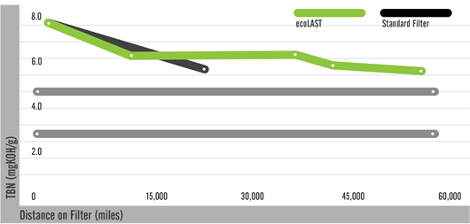
ecoLAST™ Filters Last and Last
With federal regulations mandating a reduction in emissions along with a drive for better fuel economy and potential increases in gas/oil taxes, there was a need for a filter like ecoLAST™ filters. But as the leader in heavy duty filtration, we developed more than just a filter. With ecoLAST™ filters, we created a sustainable solution not only for today, but also for tomorrow. For more information on ecoLAST™ filters and what they can do for your fleet, your overall operating costs and the environment.

