FTE Presents a New Electro-Hydraulic Clutch Actuator for Automated Manual Transmissions
FTE automotive is adding an electro-hydraulic clutch actuator (EHCA) for commercial vehicles in OEM quality to the market. EHCA is a compact unit for a highly dynamic and precise controlling of the commercial vehicle clutch. With this innovative component in the field of double clutch systems, FTE automotive extends its entire programme of brake and clutch hydraulics. This innovation combines mechanics, hydraulics, sensors, and electronics in one unit
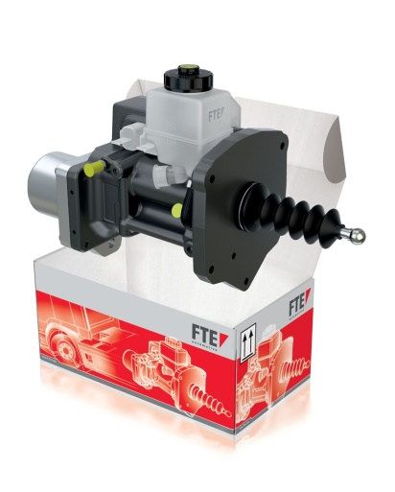
The actuator replaces the clutch pedal and the driver no longer has to think about rpm and gears to obtain the optimum actuating torque. Consequently, fuel consumption and CO2 emissions are considerably lowered. Wearing of clutch and other drive system components also decreases, enabling a longer operating life of the vehicle. “Our electro-hydraulic controlling of the automated clutch is unique in this field and offers an especially precise clutch actuation”, explained Erik Lundtoft, Executive Director Global Aftermarket at FTE automotive.
“Electro-hydraulic controlling of the automated clutch enables very precise manoeuvring and sensitive switching”, Lundtoft added. “Driving is made easier, especially in demanding driving situations, such as starting on a hill or incline.”
FTE’s electro-hydraulic clutch actuator is pre-filled with brake fluid so vehicle assembly only requires the service or workshop technician to mount the unit to the transmission and make the electrical connection.
Afterwards, the clutch will be controlled through the CAN signals.
The actuator is an integral component of original equipment in heavy goods vehicles with an automated control gear. The electro-hydraulic clutch actuator (EHCA) developed by FTE automotive is an important part of the system. It replaces the clutch pedal, the clutch master cylinder, and the clutch slave cylinder and automatically engages and disengages the clutch.
Possible sources of errors on EHCA can be quickly determined. The main electronic control unit of a truck communicates to the actuator to carry out certain functions. If deviations from reference settings occur during execution of these processes, an error code is output by the unit. Depending on the severity of the error, this code warns the driver that service is needed and to look for a workshop, where the cause of error will be determined by a vehicle diagnosis system. Independent workshops can also read the fault memory with help of a standard diagnosis tool. If the fault diagnosis determines that the actuator should be replaced, there is no need to worry. The entire unit can be easily removed and a replacement simply re-installed due to the plug-and-play-function. FTE automotive provides optimum support to workshops in the form of a 24-hour delivery service and detailed removal and installation instructions.
The new electro-hydraulic actuator is available now as an original FTE spare part through vehicle parts wholesalers. Information on the product is available at TecDoc. It is possible to order the product via TecCom. Further information on the product can be found at www.fte.de

